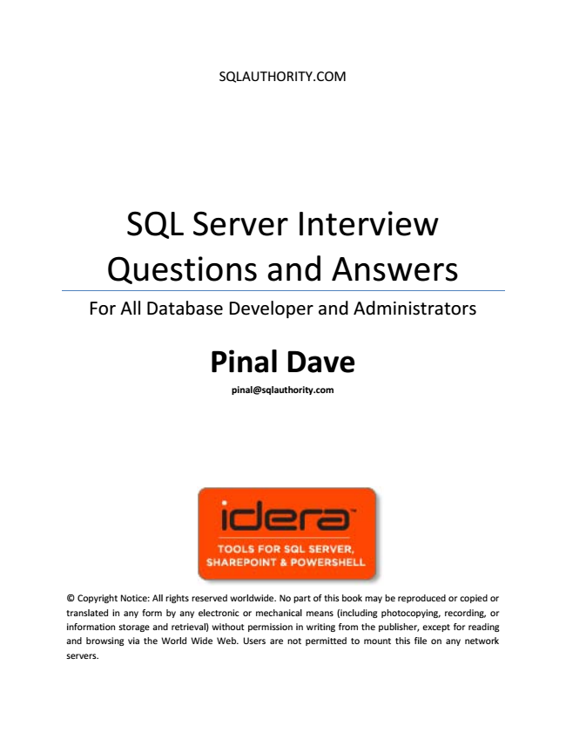

SQLAUTHORITY.COM

SQL Server Interview Questions and Answers

For All Database Developer and Administrators

**Pinal Dave**

**pinal@sqlauthority.com**

© Copyright Notice: All rights reserved worldwide. No part of this book may be reproduced or copied or translated in any form by any electronic or mechanical means (including photocopying, recording, or information storage and retrieval) without permission in writing from the publisher, except for reading and browsing via the World Wide Web. Users are not permitted to mount this file on any network servers.

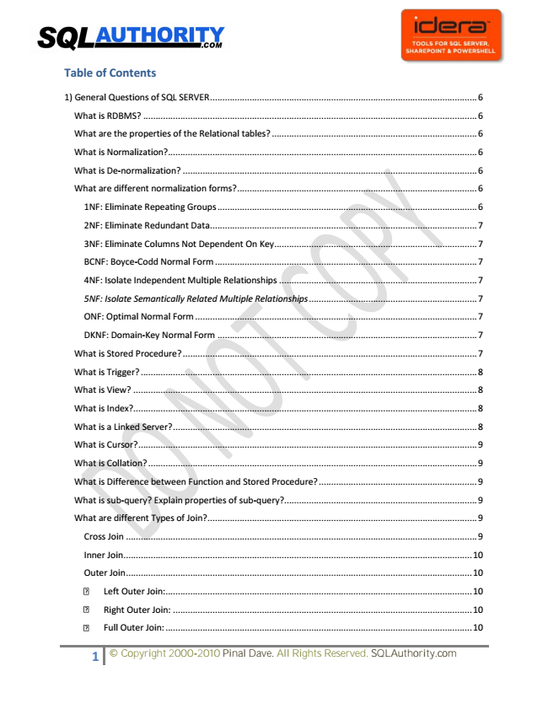

**Table of Contents**

1) General Questions of SQL SERVER ............................................................................................................ 6

What is RDBMS? ....................................................................................................................................... 6

What are the properties of the Relational tables? ................................................................................... 6

What is Normalization?............................................................................................................................. 6

What is De-normalization? ....................................................................................................................... 6

What are different normalization forms? ................................................................................................. 6

1NF: Eliminate Repeating Groups ......................................................................................................... 6

2NF: Eliminate Redundant Data ............................................................................................................ 7

3NF: Eliminate Columns Not Dependent On Key .................................................................................. 7

BCNF: Boyce-Codd Normal Form .......................................................................................................... 7

4NF: Isolate Independent Multiple Relationships ................................................................................ 7

5NF: Isolate Semantically Related Multiple Relationships .................................................................... 7

ONF: Optimal Normal Form .................................................................................................................. 7

DKNF: Domain-Key Normal Form ......................................................................................................... 7

What is Stored Procedure? ....................................................................................................................... 7

What is Trigger? ........................................................................................................................................ 8

What is View? ........................................................................................................................................... 8

What is Index?........................................................................................................................................... 8

What is a Linked Server? ........................................................................................................................... 8

What is Cursor? ......................................................................................................................................... 9

What is Collation? ..................................................................................................................................... 9

What is Difference between Function and Stored Procedure? ................................................................ 9

What is sub-query? Explain properties of sub-query? .............................................................................. 9

What are different Types of Join? ............................................................................................................. 9

Cross Join .............................................................................................................................................. 9

Inner Join ............................................................................................................................................. 10

Outer Join ............................................................................................................................................ 10

1 © Copyright 2000-2010 Pinal Dave. All Rights Reserved. SQLAuthority.com

Left Outer Join: ............................................................................................................................ 10

Right Outer Join: ......................................................................................................................... 10

Full Outer Join: ............................................................................................................................ 10

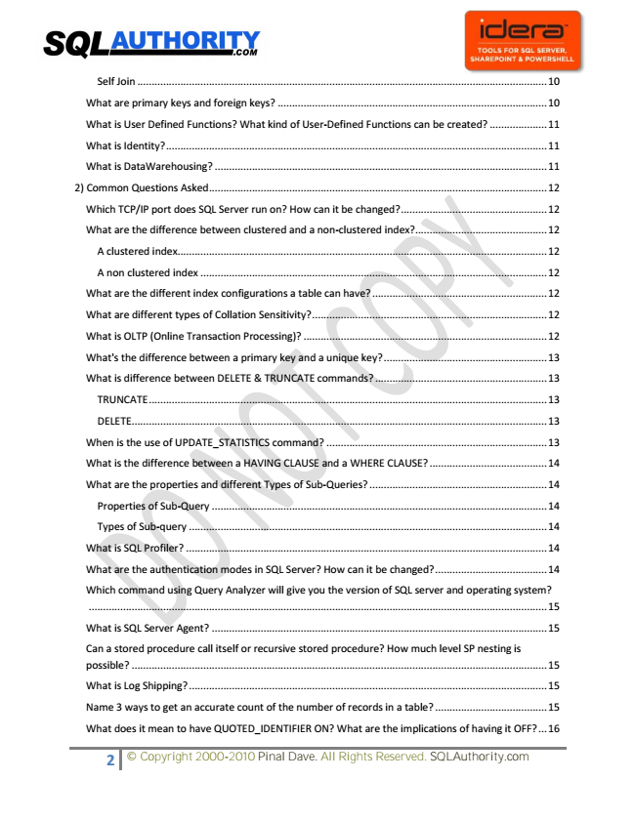

Self Join ............................................................................................................................................... 10

What are primary keys and foreign keys? .............................................................................................. 10

What is User Defined Functions? What kind of User-Defined Functions can be created? .................... 11

What is Identity? ..................................................................................................................................... 11

What is DataWarehousing? .................................................................................................................... 11

2) Common Questions Asked ...................................................................................................................... 12

Which TCP/IP port does SQL Server run on? How can it be changed? ................................................... 12

What are the difference between clustered and a non-clustered index? .............................................. 12

A clustered index................................................................................................................................. 12

A non clustered index ......................................................................................................................... 12

What are the different index configurations a table can have? ............................................................. 12

What are different types of Collation Sensitivity? .................................................................................. 12

What is OLTP (Online Transaction Processing)? ..................................................................................... 12

What's the difference between a primary key and a unique key? ......................................................... 13

What is difference between DELETE & TRUNCATE commands? ............................................................ 13

TRUNCATE ........................................................................................................................................... 13

DELETE ................................................................................................................................................. 13

When is the use of UPDATE_STATISTICS command? ............................................................................. 13

What is the difference between a HAVING CLAUSE and a WHERE CLAUSE? ......................................... 14

What are the properties and different Types of Sub-Queries? .............................................................. 14

Properties of Sub-Query ..................................................................................................................... 14

Types of Sub-query ............................................................................................................................. 14

What is SQL Profiler? .............................................................................................................................. 14

What are the authentication modes in SQL Server? How can it be changed? ....................................... 14

Which command using Query Analyzer will give you the version of SQL server and operating system?

................................................................................................................................................................ 15

What is SQL Server Agent? ..................................................................................................................... 15

Can a stored procedure call itself or recursive stored procedure? How much level SP nesting is possible? ................................................................................................................................................. 15

What is Log Shipping? ............................................................................................................................. 15

Name 3 ways to get an accurate count of the number of records in a table? ....................................... 15

What does it mean to have QUOTED_IDENTIFIER ON? What are the implications of having it OFF? ... 16

2 © Copyright 2000-2010 Pinal Dave. All Rights Reserved. SQLAuthority.com

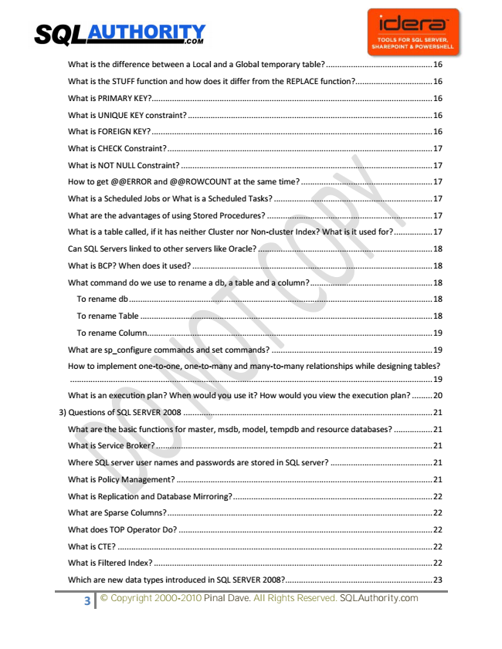

What is the difference between a Local and a Global temporary table? ............................................... 16

What is the STUFF function and how does it differ from the REPLACE function? .................................. 16

What is PRIMARY KEY?............................................................................................................................ 16

What is UNIQUE KEY constraint? ............................................................................................................ 16

What is FOREIGN KEY? ............................................................................................................................ 16

What is CHECK Constraint? ..................................................................................................................... 17

What is NOT NULL Constraint? ............................................................................................................... 17

How to get @@ERROR and @@ROWCOUNT at the same time? .......................................................... 17

What is a Scheduled Jobs or What is a Scheduled Tasks? ...................................................................... 17

What are the advantages of using Stored Procedures? ......................................................................... 17

What is a table called, if it has neither Cluster nor Non-cluster Index? What is it used for? ................. 17

Can SQL Servers linked to other servers like Oracle? ............................................................................. 18

What is BCP? When does it used? .......................................................................................................... 18

What command do we use to rename a db, a table and a column? ...................................................... 18

To rename db ...................................................................................................................................... 18

To rename Table ................................................................................................................................. 18

To rename Column .............................................................................................................................. 19

What are sp_configure commands and set commands? ....................................................................... 19

How to implement one-to-one, one-to-many and many-to-many relationships while designing tables?

................................................................................................................................................................ 19

What is an execution plan? When would you use it? How would you view the execution plan? ......... 20

3) Questions of SQL SERVER 2008 .............................................................................................................. 21

What are the basic functions for master, msdb, model, tempdb and resource databases? ................. 21

What is Service Broker? .......................................................................................................................... 21

Where SQL server user names and passwords are stored in SQL server? ............................................. 21

What is Policy Management? ................................................................................................................. 21

What is Replication and Database Mirroring? ........................................................................................ 22

What are Sparse Columns? ..................................................................................................................... 22

What does TOP Operator Do? ................................................................................................................ 22

What is CTE? ........................................................................................................................................... 22

What is Filtered Index? ........................................................................................................................... 22

Which are new data types introduced in SQL SERVER 2008?................................................................. 23

3 © Copyright 2000-2010 Pinal Dave. All Rights Reserved. SQLAuthority.com

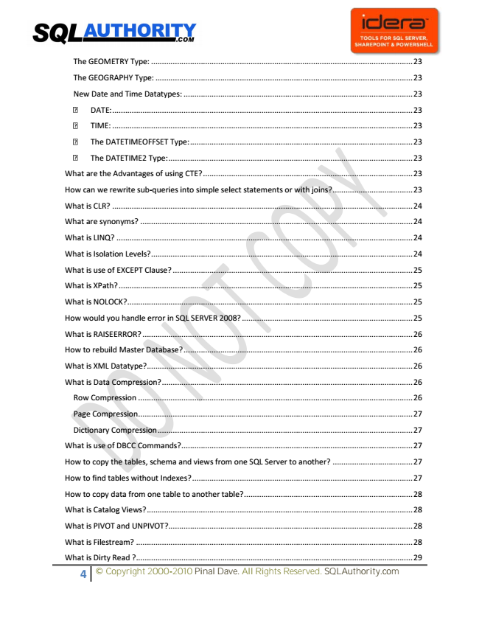

The DATETIME2 Type: ................................................................................................................. 23

What are the Advantages of using CTE? ................................................................................................. 23

How can we rewrite sub-queries into simple select statements or with joins? ..................................... 23

What is CLR? ........................................................................................................................................... 24

What are synonyms? .............................................................................................................................. 24

What is LINQ? ......................................................................................................................................... 24

What is Isolation Levels? ......................................................................................................................... 24

What is use of EXCEPT Clause? ............................................................................................................... 25

What is XPath? ........................................................................................................................................ 25

What is NOLOCK? .................................................................................................................................... 25

How would you handle error in SQL SERVER 2008? ............................................................................... 25

What is RAISEERROR? ............................................................................................................................. 26

How to rebuild Master Database? .......................................................................................................... 26

What is XML Datatype? ........................................................................................................................... 26

What is Data Compression? .................................................................................................................... 26

Row Compression ............................................................................................................................... 26

Page Compression ............................................................................................................................... 27

Dictionary Compression ...................................................................................................................... 27

What is use of DBCC Commands? ........................................................................................................... 27

How to copy the tables, schema and views from one SQL Server to another? ..................................... 27

How to find tables without Indexes? ...................................................................................................... 27

How to copy data from one table to another table? .............................................................................. 28

What is Catalog Views? ........................................................................................................................... 28

What is PIVOT and UNPIVOT? ................................................................................................................. 28

What is Filestream? ................................................................................................................................ 28

What is Dirty Read ? ................................................................................................................................ 29

The GEOMETRY Type: ......................................................................................................................... 23

The GEOGRAPHY Type: ....................................................................................................................... 23

New Date and Time Datatypes: .......................................................................................................... 23

4 © Copyright 2000-2010 Pinal Dave. All Rights Reserved. SQLAuthority.com

DATE: ........................................................................................................................................... 23

TIME: ........................................................................................................................................... 23

The DATETIMEOFFSET Type: ....................................................................................................... 23

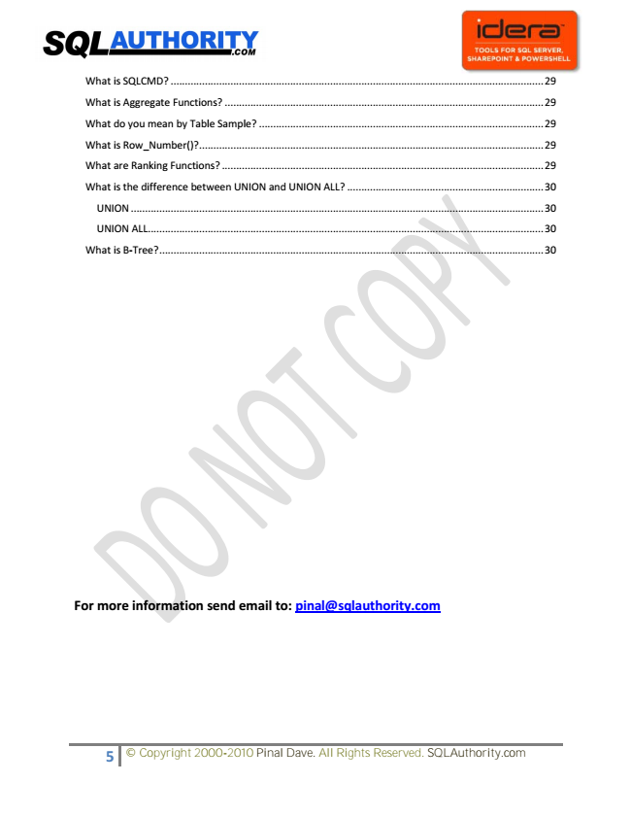

What is SQLCMD? ................................................................................................................................... 29

What is Aggregate Functions? ................................................................................................................ 29

What do you mean by Table Sample? .................................................................................................... 29

What is Row_Number()? ......................................................................................................................... 29

What are Ranking Functions? ................................................................................................................. 29

What is the difference between UNION and UNION ALL? ..................................................................... 30

UNION ................................................................................................................................................. 30

UNION ALL ........................................................................................................................................... 30

What is B-Tree? ....................................................................................................................................... 30

**For more information send email to: pinal@sqlauthority.com**

5 © Copyright 2000-2010 Pinal Dave. All Rights Reserved. SQLAuthority.com

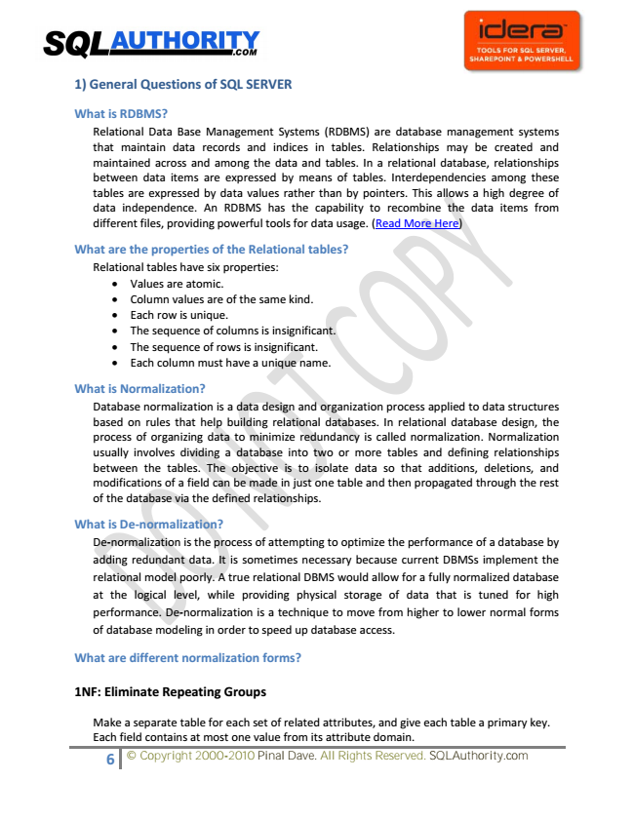

**1) General Questions of SQL SERVER**

**What is RDBMS?**

Relational Data Base Management Systems (RDBMS) are database management systems that maintain data records and indices in tables. Relationships may be created and maintained across and among the data and tables. In a relational database, relationships between data items are expressed by means of tables. Interdependencies among these tables are expressed by data values rather than by pointers. This allows a high degree of data independence. An RDBMS has the capability to recombine the data items from different files, providing powerful tools for data usage. (Read More Here)

**What are the properties of the Relational tables?**

Relational tables have six properties:

• Values are atomic.

• Column values are of the same kind.

• Each row is unique.

• The sequence of columns is insignificant.

• The sequence of rows is insignificant.

• Each column must have a unique name.

**What is Normalization?**

Database normalization is a data design and organization process applied to data structures based on rules that help building relational databases. In relational database design, the process of organizing data to minimize redundancy is called normalization. Normalization usually involves dividing a database into two or more tables and defining relationships between the tables. The objective is to isolate data so that additions, deletions, and modifications of a field can be made in just one table and then propagated through the rest of the database via the defined relationships.

**What is De-normalization?**

De-normalization is the process of attempting to optimize the performance of a database by adding redundant data. It is sometimes necessary because current DBMSs implement the relational model poorly. A true relational DBMS would allow for a fully normalized database at the logical level, while providing physical storage of data that is tuned for high performance. De-normalization is a technique to move from higher to lower normal forms of database modeling in order to speed up database access.

**What are different normalization forms?**

**1NF: Eliminate Repeating Groups**

Make a separate table for each set of related attributes, and give each table a primary key. Each field contains at most one value from its attribute domain.

6 © Copyright 2000-2010 Pinal Dave. All Rights Reserved. SQLAuthority.com

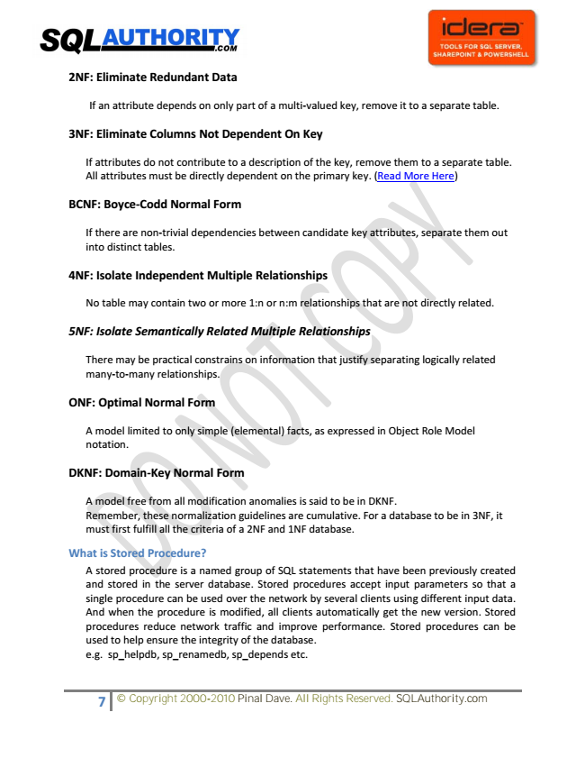

**2NF: Eliminate Redundant Data**

If an attribute depends on only part of a multi-valued key, remove it to a separate table.

**3NF: Eliminate Columns Not Dependent On Key**

If attributes do not contribute to a description of the key, remove them to a separate table. All attributes must be directly dependent on the primary key. (Read More Here)

**BCNF: Boyce-Codd Normal Form**

If there are non-trivial dependencies between candidate key attributes, separate them out into distinct tables.

**4NF: Isolate Independent Multiple Relationships**

No table may contain two or more 1:n or n:m relationships that are not directly related.

***5NF: Isolate Semantically Related Multiple Relationships***

There may be practical constrains on information that justify separating logically related many-to-many relationships.

**ONF: Optimal Normal Form**

A model limited to only simple (elemental) facts, as expressed in Object Role Model notation.

**DKNF: Domain-Key Normal Form**

A model free from all modification anomalies is said to be in DKNF. Remember, these normalization guidelines are cumulative. For a database to be in 3NF, it must first fulfill all the criteria of a 2NF and 1NF database.

**What is Stored Procedure?**

A stored procedure is a named group of SQL statements that have been previously created and stored in the server database. Stored procedures accept input parameters so that a single procedure can be used over the network by several clients using different input data. And when the procedure is modified, all clients automatically get the new version. Stored procedures reduce network traffic and improve performance. Stored procedures can be used to help ensure the integrity of the database. e.g. sp_helpdb, sp_renamedb, sp_depends etc.

7 © Copyright 2000-2010 Pinal Dave. All Rights Reserved. SQLAuthority.com

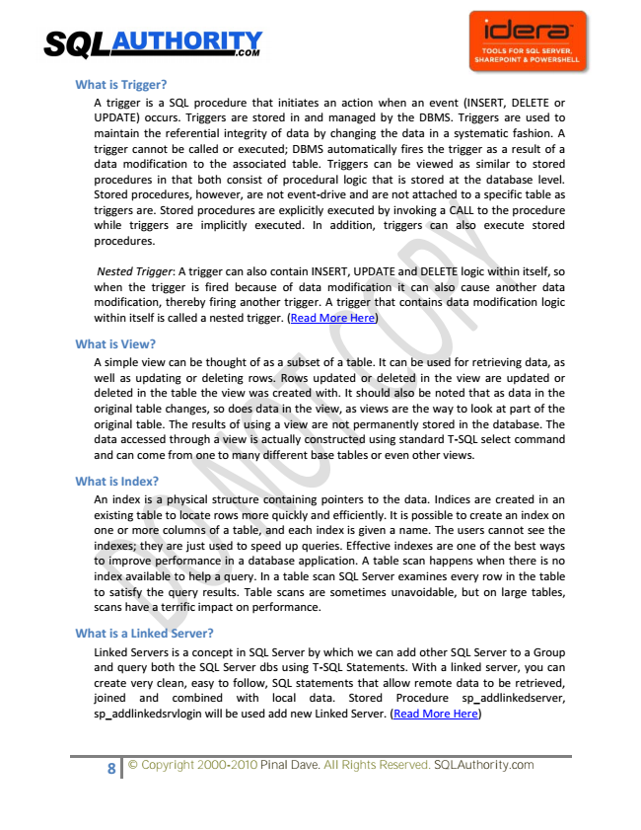

**What is Trigger?**

A trigger is a SQL procedure that initiates an action when an event (INSERT, DELETE or UPDATE) occurs. Triggers are stored in and managed by the DBMS. Triggers are used to maintain the referential integrity of data by changing the data in a systematic fashion. A trigger cannot be called or executed; DBMS automatically fires the trigger as a result of a data modification to the associated table. Triggers can be viewed as similar to stored procedures in that both consist of procedural logic that is stored at the database level. Stored procedures, however, are not event-drive and are not attached to a specific table as triggers are. Stored procedures are explicitly executed by invoking a CALL to the procedure while triggers are implicitly executed. In addition, triggers can also execute stored procedures.

Nested Trigger: A trigger can also contain INSERT, UPDATE and DELETE logic within itself, so when the trigger is fired because of data modification it can also cause another data modification, thereby firing another trigger. A trigger that contains data modification logic within itself is called a nested trigger. (Read More Here)

**What is View?**

A simple view can be thought of as a subset of a table. It can be used for retrieving data, as well as updating or deleting rows. Rows updated or deleted in the view are updated or deleted in the table the view was created with. It should also be noted that as data in the original table changes, so does data in the view, as views are the way to look at part of the original table. The results of using a view are not permanently stored in the database. The data accessed through a view is actually constructed using standard T-SQL select command and can come from one to many different base tables or even other views.

**What is Index?**

An index is a physical structure containing pointers to the data. Indices are created in an existing table to locate rows more quickly and efficiently. It is possible to create an index on one or more columns of a table, and each index is given a name. The users cannot see the indexes; they are just used to speed up queries. Effective indexes are one of the best ways to improve performance in a database application. A table scan happens when there is no index available to help a query. In a table scan SQL Server examines every row in the table to satisfy the query results. Table scans are sometimes unavoidable, but on large tables, scans have a terrific impact on performance.

**What is a Linked Server?**

Linked Servers is a concept in SQL Server by which we can add other SQL Server to a Group and query both the SQL Server dbs using T-SQL Statements. With a linked server, you can create very clean, easy to follow, SQL statements that allow remote data to be retrieved, joined and combined with local data. Stored Procedure sp_addlinkedserver, sp_addlinkedsrvlogin will be used add new Linked Server. (Read More Here)

8 © Copyright 2000-2010 Pinal Dave. All Rights Reserved. SQLAuthority.com

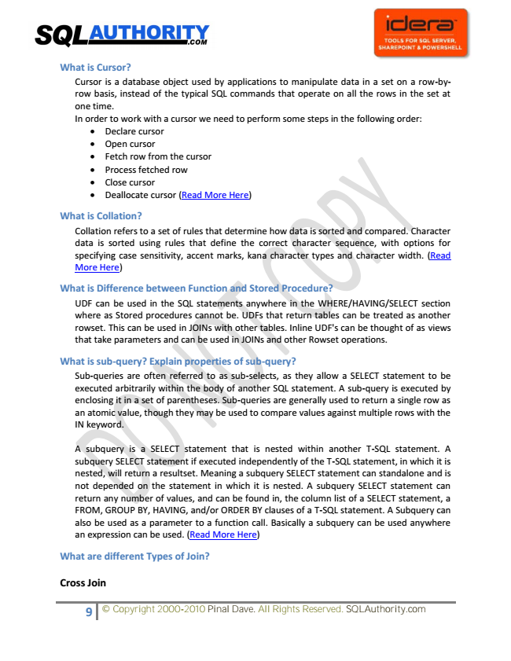

**What is Cursor?**

Cursor is a database object used by applications to manipulate data in a set on a row-by- row basis, instead of the typical SQL commands that operate on all the rows in the set at one time. In order to work with a cursor we need to perform some steps in the following order:

• Declare cursor

• Open cursor

• Fetch row from the cursor

• Process fetched row

• Close cursor

• Deallocate cursor (Read More Here)

**What is Collation?**

Collation refers to a set of rules that determine how data is sorted and compared. Character data is sorted using rules that define the correct character sequence, with options for specifying case sensitivity, accent marks, kana character types and character width. (Read More Here)

**What is Difference between Function and Stored Procedure?**

UDF can be used in the SQL statements anywhere in the WHERE/HAVING/SELECT section where as Stored procedures cannot be. UDFs that return tables can be treated as another rowset. This can be used in JOINs with other tables. Inline UDF's can be thought of as views that take parameters and can be used in JOINs and other Rowset operations.

**What is sub-query? Explain properties of sub-query?**

Sub-queries are often referred to as sub-selects, as they allow a SELECT statement to be executed arbitrarily within the body of another SQL statement. A sub-query is executed by enclosing it in a set of parentheses. Sub-queries are generally used to return a single row as an atomic value, though they may be used to compare values against multiple rows with the IN keyword.

A subquery is a SELECT statement that is nested within another T-SQL statement. A subquery SELECT statement if executed independently of the T-SQL statement, in which it is nested, will return a resultset. Meaning a subquery SELECT statement can standalone and is not depended on the statement in which it is nested. A subquery SELECT statement can return any number of values, and can be found in, the column list of a SELECT statement, a FROM, GROUP BY, HAVING, and/or ORDER BY clauses of a T-SQL statement. A Subquery can also be used as a parameter to a function call. Basically a subquery can be used anywhere an expression can be used. (Read More Here)

**What are different Types of Join?**

**Cross Join**

9 © Copyright 2000-2010 Pinal Dave. All Rights Reserved. SQLAuthority.com